224% Traffic Growth for a Military Defense Law Firm

SEO

Results that speak for themselves

Key Stats & Results


224% Increase in site traffic

231% Increase in users

Behind the transformation

Global SEO for Lawyers: 224% Traffic Growth for a Military Defense Firm
A global military criminal defense law firm partnered with Rankings.io to expand its organic visibility and reach service members stationed around the world. Through a specialized SEO strategy built for a niche, non-geographic legal practice, the firm achieved a 224% increase in site traffic, grew its backlink profile from 32 to more than 1,400 links, and secured first-page rankings for high-intent military law keywords. The result was a scalable pipeline of qualified leads from clients stationed across the United States, Europe, Asia, and the Middle East.
.

FROM CHALLANGES TO SUCCESS


The Challenge
When this military criminal defense law firm partnered with Rankings.io, the challenge was unlike anything a typical personal injury or family law firm faces: The practice needed clients to discover it not just locally, but globally.
The firm's founder is a civilian court-martial defense attorney who represents military members and their families wherever they're stationed or serving—across the USA, Europe, South Korea, Japan, the Middle East, and dozens of other countries. It's a uniquely niche practice that demands a fundamentally different approach to SEO.
The core problem was discoverability at scale. Potential clients in active military service needed to be able to find the firm through organic search, regardless of whether the military stationed them in Japan, Turkey, Oklahoma, Hawaii, or anywhere else in the world. Standard local SEO tactics built around geography simply did not serve this purpose.
When the firm first engaged Rankings.io, its backlink profile was critically underdeveloped—just 32 backlinks, with a fragmented and inactive social media presence . Competition within the military law niche is limited, but the global stage meant the firm still needed to clearly outrank all alternatives in search results.
Adding to the complexity: Military law requires a completely separate keyword strategy. The same search terms that drive civilian criminal defense traffic don’t apply to military law. Any SEO provider would need a deep understanding of the space to build an effective strategy.
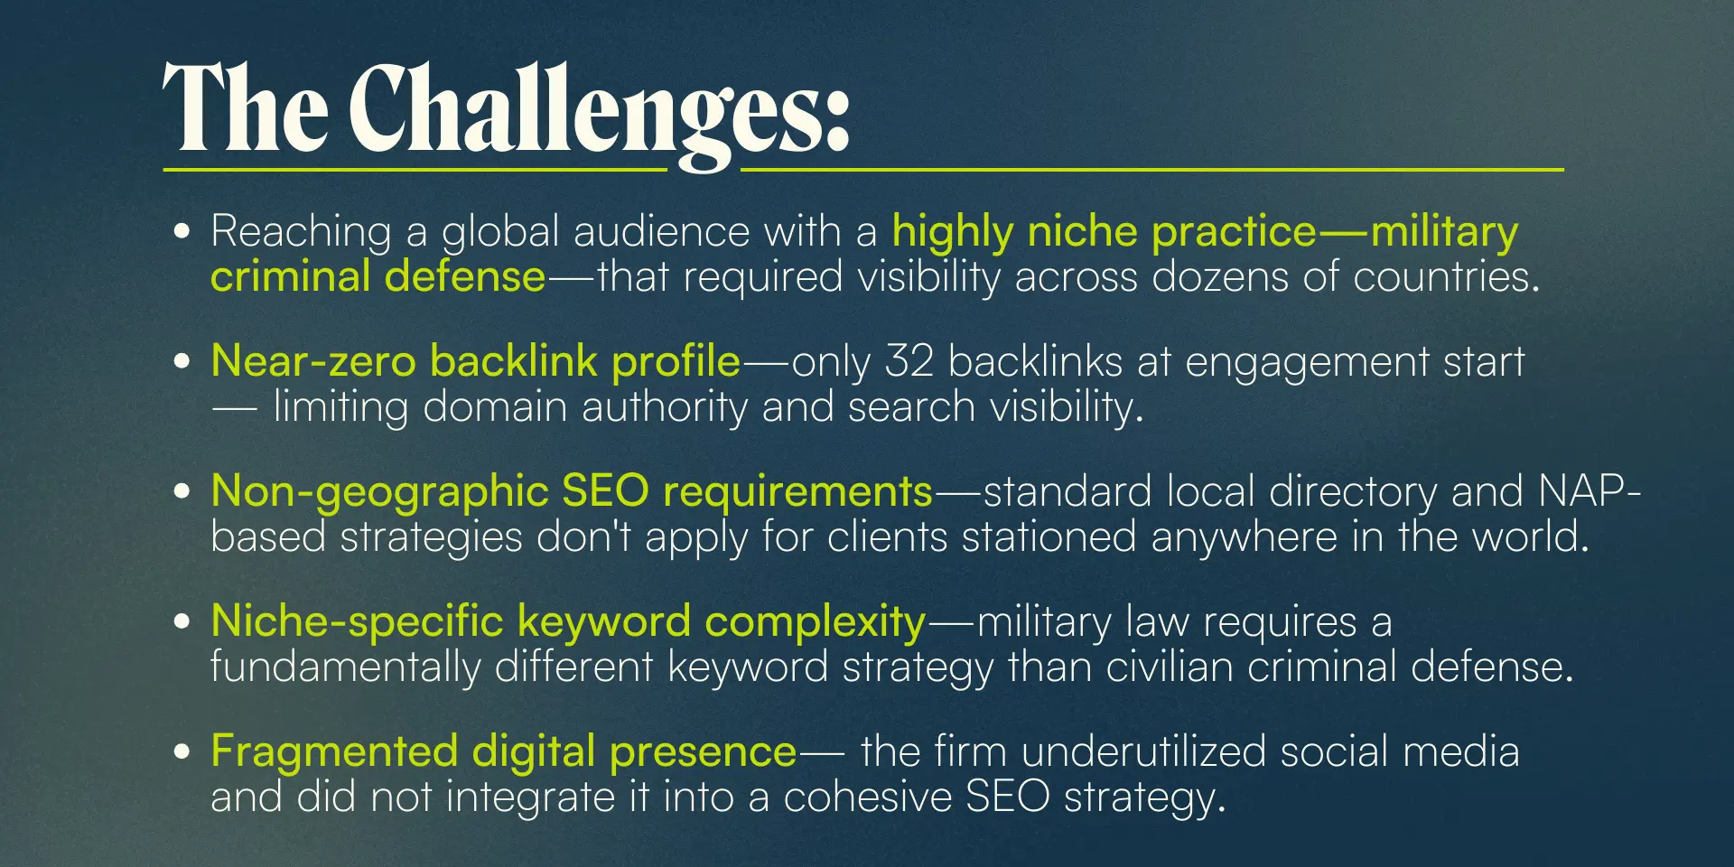



How We Did It: The Strategy
Rankings.io implemented a comprehensive SEO program tailored specifically to the realities of a global, niche military law practice. Rather than applying a standard legal SEO template, we built every element of the strategy around the firm's unique geographic and practice-area requirements.

SEO Strategy for a Military Defense Law Firm
We designed the approach to establish authority in a niche where traditional local signals don't apply, building a link profile and content ecosystem that could perform across all major search markets simultaneously.

1. Full Website Assessment & Technical Foundation
Rankings.io began with a complete website audit, identifying which existing elements worked and which needed improvement. We fully optimized on-site and off-site assets before we began any link-building activity, ensuring search engines could correctly index and prioritize the firm's most important pages.

2. Niche-Specific Keyword Strategy
Military law requires an entirely different keyword framework than civilian criminal defense. Rankings.io developed a tailored keyword strategy that reflected how military service members and their families actually search for legal help, accounting for the specialized terminology, procedures, and concerns unique to military justice.

3. Non-Geographic Link Building
Because the firm's clients can be stationed anywhere in the world, standard NAP-based and local directory link-building strategies did not apply. Instead, Rankings.io developed a robust, authority-first link-building campaign targeting prominent defense attorney platforms, niche legal publications, and guest blogging opportunities, building a backlink profile that carried authority globally rather than locally.

4. Social Media Integration & Content Strategy
We restructured the firm's existing social media presence, including LinkedIn, Facebook, and other platforms, into a cohesive, integrated strategy. Rankings.io supported consistent blog content ideation and publication, reinforcing the firm's topical authority and extending its digital footprint across channels.

5. Ongoing Optimization & Transparent Reporting
Throughout the engagement, Rankings.io maintained consistent communication, monthly performance reporting, and a pipeline of new link-building and optimization opportunities. We executed the strategy through entirely ethical, white-hat SEO. We used no tactics that could risk a Google penalty, only sustainable authority-building that compounds with time.



Before & After
After executing a comprehensive, niche-first SEO strategy, the firm achieved sustained growth across every key performance metric: traffic, users, backlinks, and lead quality.
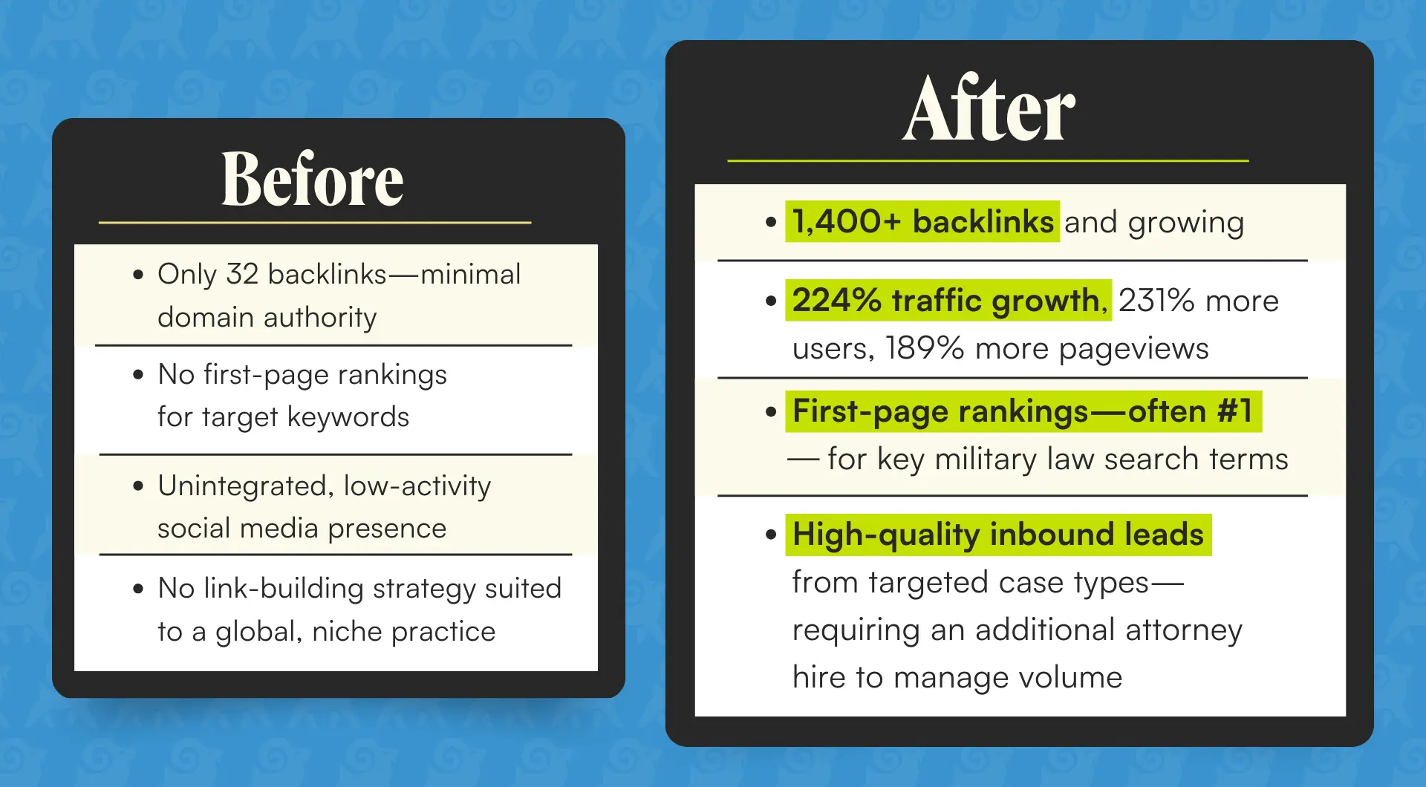

Key Wins
- 224% increase in site traffic with sustained year-over-year growth
- 231% increase in users and 189% more pageviews
- Backlink profile scaled from 32 to 1,400+ through ethical, white-hat link building
- First-page rankings—frequently #1—for primary military law keywords
- Global search visibility—inbound leads now arrive from clients stationed across the USA, Europe, Japan, South Korea, the Middle East, and beyond
- Lead quality improved alongside volume—the firm now attracts its ideal case types at scale, requiring an additional attorney hire to handle inbound demand
- Revenue increased significantly—the SEO investment paid for itself through new case volume and improved client quality

Ready to Grow Your Firm?
This case study demonstrates that even the most niche, geographically unconventional law practices can achieve dominant search visibility with the right SEO strategy.
At Rankings.io, we specialize exclusively in digital marketing for lawyers. We understand that no two practices are the same and we build strategies that reflect the real complexity of your market.
Whether you serve a local market or a global one, our approach to technical SEO, content authority, and ethical link building delivers results that compound over time.

